REMOTE APP

Aim:  
 To develop a smart home control app that allows users to effortlessly manage and monitor connected devices, ensuring convenience and a seamless user experience.

Procedure:

STEP 1: Set up frames for each screen, ensuring they match the dimensions of an iPhone 14.

STEP 2: Design the onboarding screens with the app name, illustrations, and a "Get Started" button.

STEP 3: Create the device selection screen with icons representing various smart devices.

STEP 4: Design control screens for each device, incorporating sliders, buttons, and color pickers

STEP 5: Link the screens together in a prototype to simulate navigation and device control interactions.

Prototype:

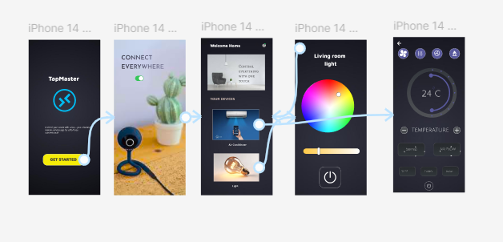

Result:  
 A streamlined mobile app that enables users to control various smart home devices, adjust settings, and monitor their environment through an intuitive and responsive interface.